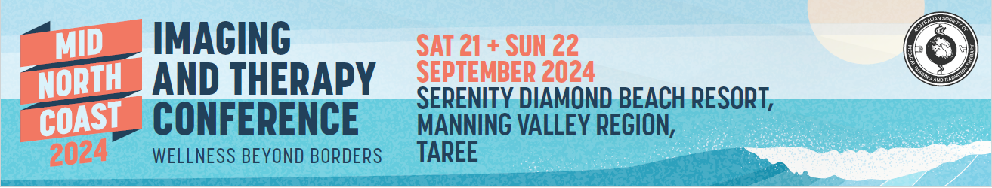
Abstract Submission Form
Mid North Coast Imaging and Therapy Conference 2024
Saturday 21 & Sunday 22 September 2024
ASMIRT Mid North Coast committee welcomes all submissions for oral presentations for their 2024 Mid North Coast Imaging and Therapy Education Weekend. Topics can include any research projects, interesting case studies or new practices/ procedures. All submissions are to include a fully completed Abstract Submission Form.
- Oral presentations will run for duration of 12 minutes with 3 minutes question time. Time limits will be enforced so that the day runs to time.
- Please submit completed Abstract Submission Form to the ASMIRT MNC Committee via email Gary.Denham@health.nsw.gov.au;
CC: shanemaria.howell@asmirt.org click here
- Receipt of your submission will be acknowledged by email.
- Abstract submission closes: Monday 15 July 2024
Presenter name:
Email:
Mobile number:
Affiliation:
Job Title / Position
Co-author/s and their affiliations:
Modality: | □ Nuclear Medicine | □ Medical Imaging
 | □ Radiation Therapy | □ Sonography
 | □ Other:
University details: | University: ________________________________
 | Year level at 21 September 2024:
Abstract type: | □ Scientific | □ Non-scientific (incl. case studies)
Abstract title:
Word limit: 25
Abstract body:
Word limit: 250
(not including references)

Scientific abstract structure:
Objectives, Methods, Results, Conclusion (and References if applicable)

Non-scientific abstract structure:
Headings not required
Biography:
Word limit: 100
As this will be used to introduce you (if successful) please write in the third person eg Mary is…

