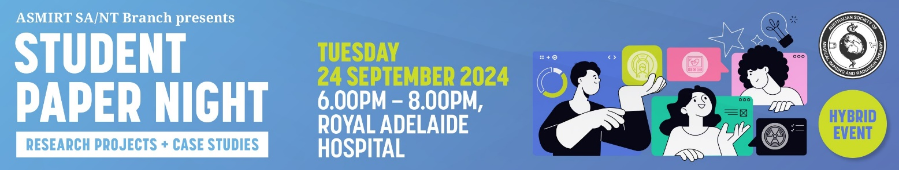

ASMIRT STUDENT PAPER PRESENTATION NIGHT
Tuesday 24 September 2024
6.00 pm
The SA/NT Branch of ASMIRT are seeking expressions of interest from South Australian and Northern Territory student members who would like to prepare a 11+3 =14 minute presentation for the Student Paper Presentation meeting on Tuesday 24th September 2024, beginning at 6.00pm. A paper of suitable standard from those presented will be chosen for the Best Presentation prize, which consists of $1,500 to assist in attendance and participation at ASMIRT’s Annual Conference being held in Adelaide, 2025. There are 3 prizes available, one for each of medical imaging, nuclear medicine and radiation therapy student presentations. The successful student members would represent SA/NT in the Student Prize Winner session of the main conference and compete for the National Student Prize. This is a great opportunity to become involved with radiographers and radiation therapists from all over Australia and overseas.
Papers are usually an individual effort, but joint presentations are also acceptable. There are various topic areas and styles you can choose for presentation. Topics in your modality covering techniques, recent developments, patient care and organization/process development are all relevant. Literature reviews of comparative techniques, as well as case studies which illustrate the effectiveness/ineffectiveness of a certain process are common approaches.
This will be a hybrid event to allow NT students to present remotely.
If you are interested, we ask that you complete and submit the abstract submission form provided below and email it to santbr@asmirtcommittee.org by Friday 6 September. Once the committee has reviewed all the abstracts, the successful students will receive notification of who will be included on the program.
If you would like more information or if you have any questions about this process, please contact the SA/NT Branch at santbr@asmirtcommittee.org or the ASMIRT Events Team at events@asmirt.org or on 03 9419 3336.
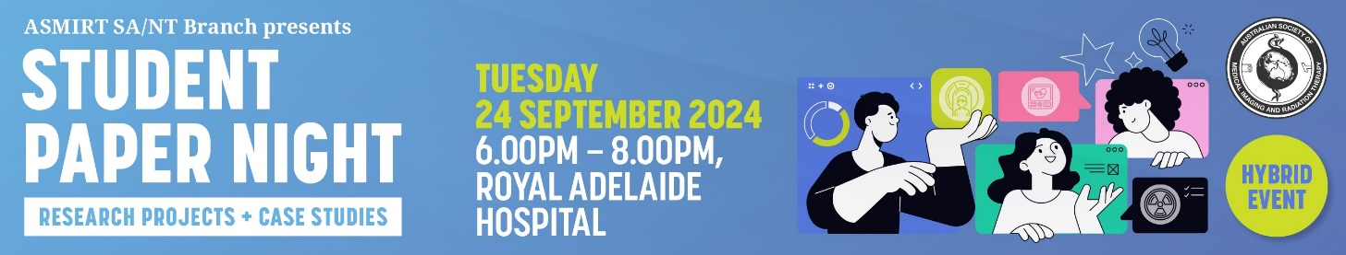

ABSTRACT SUBMISSION FORM

All presentations are 14 mins in total, 11 mins speaking and 3 mins for questions

TITLE OF ABSTRACT:
Word limit: 15

Author’s Name/s:

Contact email:
Mobile Number:
Discipline:
University and Year level
Biography:
Word limit: 100
As this will be used to introduce you (if successful) please write in the third person
e.g. Mary is…
Abstract:
Text should be 11 point single spaced and should be limited to 250 words.
Headings to be used:
Aim/Background, Methods, Results, Conclusion
Aim/ Background: Shortest part of the abstract, 2-3 sentences, brief introduction that establishes rationale for the work
Methods: 2-3 sentences, should describe the approach to test your aim, including what was done and how it was done.
Results: 3-5 sentences, state results clearly & concisely, limit to results that answer your question, emphasise the highest impact results, include significant statistics. State in a logical order in the same way you have outlined your method.
Conclusion: Most important 2-3 sentences of the
abstract. States the “what does it really mean”, may
include future directions.
References:
References should be included if they support the abstract and must be directly cited in the abstract using the Vancouver referencing style as used by JMRS.
Please send this abstract to santbr@asmirtcommittee.org

