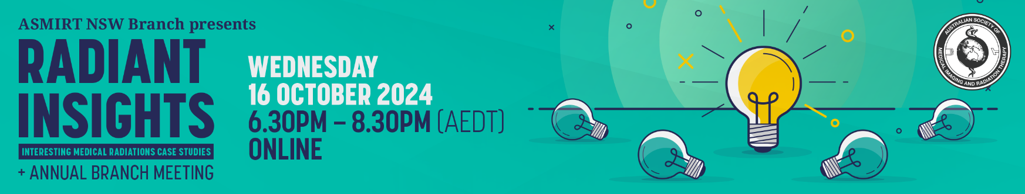Abstract Submission Form

2024 ASMIRT NSW BRANCH RADIANT INSIGHTS

Have you encountered an interesting case study? If so, this is for you! ASMIRT NSW Branch committee welcomes all submissions for oral presentations for their 2024 RADIANT INSIGHTS night. Topics can include any interesting and insightful case studies. All submissions are to include a fully completed Abstract Submission Form.

* Oral presentations will run for duration of **8** minutes with 2 minutes question time. Time limits will be enforced so that the day runs to time.
* Please submit completed Abstract Submission Form, as a Word document, to: [nswbr@asmirtcommittee.org](mailto:nswbr@asmirtcommittee.org) and CC: [shanemaria.howell@asmirt.org](mailto:shanemaria.howell@asmirt.org)
* Receipt of your submission will be acknowledged by email.
* **Abstract submission closes: Friday 27th September 2024**

|  |  |  |
| --- | --- | --- |
| **Presenter name:** |  | |
| **Email:** |  | |
| **Mobile number:** |  | |
| **Job Title:** |  | |
| **Affiliation:** |  | |
| **Co-author/s and their affiliations:** |  | |
| **Modality:** | □ Nuclear Medicine | □ Medical Imaging |
| □ Radiation Therapy | □ Sonography |
| □ Other: ______________________ | |
| **University details:** | University: ________________________________ | |
| Year level at 27 September 2024: ____________ | |
| **Abstract type:** | □ Scientific | □ Non-scientific (incl. case studies) |
| **Abstract title:**  *Word limit: 25* |  | |
| **Abstract body:**  *Word limit: 250*  (not including references)  **Scientific abstract structure:**  Objectives, Methods, Results, Conclusion (and References if applicable)  **Non-scientific abstract structure:**  Headings not required |  | |
| **Biography:**  *Word limit: 100*  As this will be used to introduce you (if successful) please write in the third person eg Mary is… |  | |