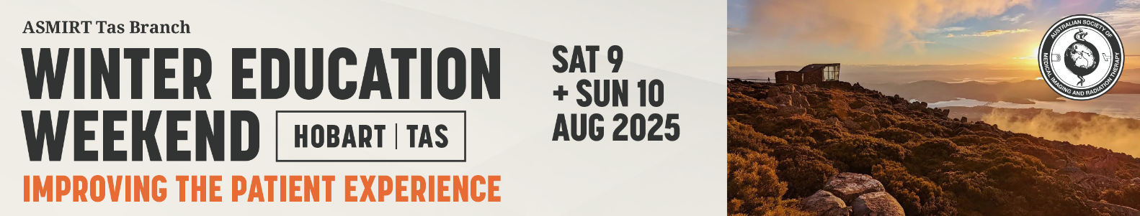

Abstract Submission Form

2025 Tasmania Winter Education Weekend

Saturday 9 & Sunday 10 August 2025

ASMIRT Tas Branch committee welcomes all submissions for oral presentations for their 2025 Tasmania Winter Education Weekend. Topics can include any research projects, interesting case studies or new practices/procedures. All submissions are to include a fully completed Abstract Submission Form.

* Oral presentations will run for duration of **12** minutes with 2 minutes question time. Time limits will be enforced so that the day runs to time.
* Please submit completed Abstract Submission Form to the ASMIRT Tas Branch at [tasbr@asmirtcommittee.org](mailto:tasbr@asmirtcommittee.org)
* Receipt of your submission will be acknowledged by email.
* **Abstract submission closes: Friday 30 May 2025**

|  |  |  |
| --- | --- | --- |
| **Presenter name:** |  | |
| **Email:** |  | |
| **Mobile number:** |  | |
| **Affiliation:** |  | |
| **Job Title / Position** |  | |
| **Co-author/s and their affiliations:** |  | |
| **Modality:** | □ Nuclear Medicine | □ Medical Imaging |
| □ Radiation Therapy | □ Sonography |
| □ Other: ______________________ | |
| **University details:** | University: ________________________________ | |
| Year level at 9 August 2025: ____________ | |
| **Abstract type:** | □ Scientific | □ Non-scientific (incl. case studies) |
| **Abstract title:**  *Word limit: 25* |  | |
| **Abstract body:**  *Word limit: 250*  (not including references)  **Scientific abstract structure:**  Objectives, Methods, Results, Conclusion (and References if applicable)  **Non-scientific abstract structure:**  Headings not required |  | |
| **Biography:**  *Word limit: 100*  As this will be used to introduce you (if successful) please write in the third person eg Mary is… |  | |