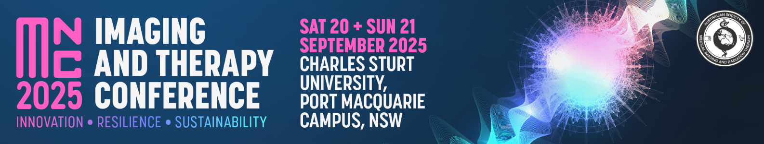

Abstract Submission Form

Mid North Coast Imaging and Therapy Conference

Saturday 20 & Sunday 21 September 2025

ASMIRT NSW Branch committee welcomes all submissions for oral presentations for their Mid North Coast Imaging and Therapy Conference to be held in Port Macquarie in September 2025. Topics can include any research projects, interesting case studies or new practices/procedures. All submissions are to include a fully completed Abstract Submission Form.

* Oral presentations will run for duration of **12** minutes with 2 minutes question time. Time limits will be enforced so that the day runs to time.
* Please submit completed Abstract Submission Form to the Organising Committee at [nswbr@asmirtcommittee.org](mailto:nswbr@asmirtcommittee.org)
* Receipt of your submission will be acknowledged by email.
* **Abstract submission closes: 30 June 2025**

|  |  |  |
| --- | --- | --- |
| **Presenter name:** |  | |
| **Email:** |  | |
| **Mobile number:** |  | |
| **Affiliation:** |  | |
| **Job Title / Position** |  | |
| **Co-author/s and their affiliations:** |  | |
| **Modality:** | □ Nuclear Medicine | □ Medical Imaging |
| □ Radiation Therapy | □ Sonography |
| □ Other: ______________________ | |
| **University details:** | University: ________________________________ | |
| Year level at 20 September 2025: ____________ | |
| **Abstract type:** | □ Scientific | □ Non-scientific (incl. case studies) |
| **Abstract title:**  *Word limit: 25* |  | |
| **Abstract body:**  *Word limit: 250*  (not including references)  **Scientific abstract structure:**  Objectives, Methods, Results, Conclusion (and References if applicable)  **Non-scientific abstract structure:**  Headings not required |  | |
| **Biography:**  *Word limit: 100*  As this will be used to introduce you (if successful) please write in the third person eg Mary is… |  | |