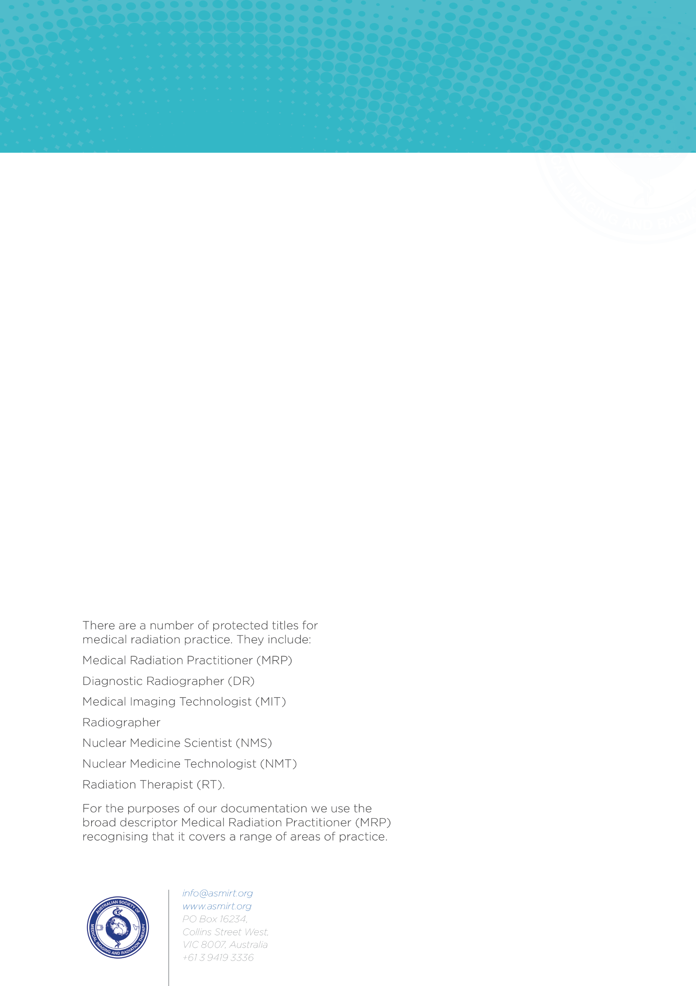
POSTGRADUATE STUDY SCHOLARSHIP APPLICATION

Instructions for preparing applications.
The application form must be filled in electronically. Any queries regarding the application should be directed to scholarships@asmirt.org.
Email the completed application (single PDF document) to the Education Committee at scholarships@asmirt.org
Closing date for applications is First Sunday in October

Section 1: Applicant Details
Title
Family Name
Given Name
Discipline | ☐ Medical Imaging ☐ Radiation Therapy ☐ Nuclear Medicine
Postal Address
 | State: | Postcode:
E-mail address
Telephone number | Work: | Mobile:
Are you of Aboriginal or Torres Strait Islander origin? | ☐ No  ☐ Yes, Aboriginal  ☐ Yes, Torres Strait Islander  ☐ Yes, both Aboriginal and Torres Strait Islander  ☐ Prefer not to say
Organisation
Department
Currently held position
Highest Academic qualification |  |  | Year Attained:

Section 2: Applicant Eligibility
ASMIRT Membership Number
I understand and confirm that I am eligible to apply for this scholarship, as I am a current financial ASMIRT voting member with continuous membership directly preceding this application of a minimum of:
☐ 3 years membership – Graduate Certificate
☐ 4 years membership – Graduate Diploma
☐ 5 years membership – Masters Degree

Section 3: Course Details
Postgraduate Study | ☐ Graduate Certificate (AQF Level 8)  ☐ Graduate Diploma (AQF Level 8)  ☐ Masters Degree* (AQF Level 9)  *Applicants enrolled in a Graduate Entry Masters (GEM) Medical Radiation Science program are not eligible to apply for this scholarship.
Duration (months/years)
Enrolment type | ☐ Full-time  ☐ Part-time
Name of Proposed Course of Study
Higher Education Provider
Proposed Start Date of Course of Study
Completion Date of Course of Study (if known)
If partway through course, please provide details (Please note: this scholarship will not be paid for retrospective study)

Please attach the entire proposed course outline, which should include the course details, duration, objectives, and structure (including subjects) and any elective subjects clearly identified. This information should come from the educational institution. Website links are not adequate.

Section 4: Selection Criteria
Please provide written statements against the following questions only, using only 10-point Arial and 1.5 line spacing. Please refer to the ASMIRT Assessment Matrix Postgraduate Scholarship document for statement assessment criteria.

- Detail the relationship between the proposed course of study and your current discipline of practice. [200 words]
______________________________________________________________________

- Demonstrate how the proposed course of study will enhance your current skills and knowledge or diversify your skills and knowledge within your current discipline of practice. [200 words]

______________________________________________________________________

- Demonstrate how the proposed course of study will improve the workforce and/or service delivery needs of your local community and improve patient care. [250 words]
______________________________________________________________________

- Discuss your personal commitment to and understanding of the need to undertake further study and professional development in your discipline of practice. [200 words]
______________________________________________________________________

Section 5: Other Sources of Funding
Have any other applications for funding been made/granted? For example, but not limited to, a commonwealth supported place (CSP), HECS-HELP, FEE-HELP, workplace support or other external organisation. If yes, from whom? Please provide supporting evidence of this funding.
☐ Yes ☐ No
______________________________________________________________________

Section 6: Resume
Please enclose a brief current resume (maximum 3 pages).

Section 7: Documentation Checklist
☐ | Confirmed eligibility to apply for this scholarship
☐ | Completed application form including applicant signature
☐ | Resume
☐ | Statements addressing the selection criteria completed
☐ | Detailed course information provided (website link is insufficient documentation)

Section 8: Declaration
8.1 Terms and Conditions
I understand and agree to the following terms and conditions.
- I will continue to maintain Australian Society of Medical Imaging and Radiation Therapy Financial voting membership for the duration of the scholarship.
- Scholarship funds will be reimbursed upon successful completion of each semester of study, in instalments, and not exceeding the lesser of the total scholarship amount or cost of the course.
- To receive the funds, evidence of receipt of payment from the higher education provider and successful completion must be provided.
- A brief yearly progress report will be required.
- Provision of a Study Reflection Report by agreed date.
- Final scholarship payment will be made upon ASMIRT’s acceptance of the report.
- The decision made by ASMIRT is final, and no further correspondence will be entertained. ASMIRT does not accept appeals regarding its decisions.

8.2 Declaration
I, the undersigned, hereby declare that the information given on this scholarship application form is correct to the best of my knowledge and understanding and agree to the terms and conditions.

Signature of applicant: ___________ Date: ___ / ___ /___

Please ensure that all documents submitted are in a PDF format, before submitting your application via email. Indicate in the covering email message the number of documents attached.

Submit this application to:

Education Committee
Australian Society of Medical Imaging and Radiation Therapy
E-mail: scholarships@asmirt.org

