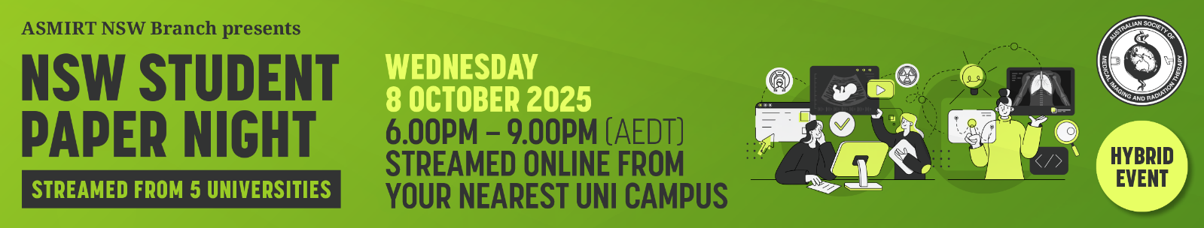
Abstract Submission Form
NSW Branch Student Paper Night
Join us for an exciting Student Paper Night! This event is a fantastic opportunity for students to showcase their research and insights on medical imaging, radiation therapy, nuclear medicine, and sonography. It’s a supportive and engaging environment where you can develop your skills, think critically, and network with peers and experts. Plus, the winner of each category will be supported to attend ASMIRT 2026 in Hobart to represent NSW and compete for the National Student Prize. Don’t miss out on this chance to learn, connect, and win!
All submissions are to include a fully completed Abstract Submission Form. Prize winners are automatically accepted to present their winning presentation at ASMIRT 2026 in Hobart 26 – 29 March 2026.
- Oral presentations will run for duration of 11 minutes with 3 minutes question time. Time limits will be enforced so that the event runs to time.
- Please submit completed Abstract Submission Form to the ASMIRT NSW Branch organising committee at events@asmirt.org
- Receipt of your submission will be acknowledged by email. You will be notified of acceptance around Wednesday 24 September 2025.
- Abstract submission closes: Wednesday 17 September 2025
- Please submit your abstract in Word format.
- Presenter is required to have obtained permission from co-authors to present at the conference.
- All presenters will present live from their respective universities and streamed to the other four university locations.
Presenter name:
Email:
Mobile number:
Affiliation:
Co-author/s and their affiliations:

Modality: | □ Nuclear Medicine | □ Medical Imaging
 | □ Radiation Therapy | □ Sonography
 | □ Other: ______________________
University details: | University: ________________________________
 | Year level at 8 October 2025: ____________
Abstract type: | □ Scientific | □ Non-scientific (incl. case studies)
Abstract title:
Word limit: 15
Abstract body:
Word limit: 250
(not including references)

Scientific abstract structure:
Objectives, Methods, Results, Conclusion (and References if applicable)

Non-scientific abstract structure:
Headings not required
References:
References should be included if they support the abstract and must be directly cited in the abstract using the Vancouver referencing style as used by JMRS.
Biography:
Word limit: 100
As this will be used to introduce you (if successful) please write in the third person
e.g. Mary is…

