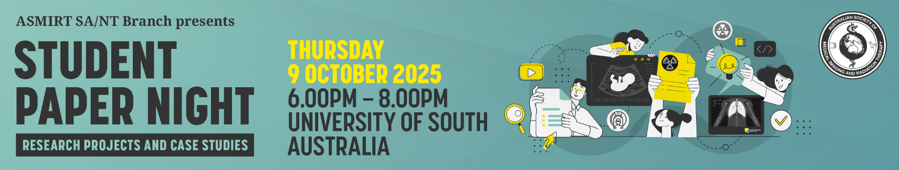

Abstract Submission Form
SA Branch Student Paper Night
ASMIRT Vic Branch committee welcomes all submissions for oral presentations for the annual student paper day. Awards will be given for the best two/three oral presentations. Award includes 12-month membership to the ASMIRT, airfare and registration to the next Annual Scientific Meeting. Results of these awards will not be made available until Mid-December 2025. All submissions are to include a fully completed Abstract Submission Form.
- Oral presentations will run for duration of 11 minutes with 3 minutes question time. Time limits will be enforced so that the day runs to time.
- Please submit completed Abstract Submission Form to the ASMIRT SA NT Branch at santbr@asmirtcommittee.org
- Receipt of your submission will be acknowledged by email. You will be notified of acceptance in early October
- Abstract submission closes: Friday 26 September 2025
Presenter name:
Email:
Mobile number:
Affiliation:
Co-author/s and their affiliations:

Modality: | □ Nuclear Medicine | □ Medical Imaging
 | □ Radiation Therapy | □ Sonography
 | □ Other: ______________________
University details: | University: ________________________________
 | Year level at 26 September 2025: ____________
Abstract type: | □ Scientific | □ Non-scientific (incl. case studies)
Abstract title:
Word limit: 15
Abstract body:
Word limit: 250
(not including references)

Scientific abstract structure:
Objectives, Methods, Results, Conclusion (and References if applicable)

Non-scientific abstract structure:
Headings not required
References:
References should be included if they support the abstract and must be directly cited in the abstract using the Vancouver referencing style as used by JMRS.
Biography:
Word limit: 100
As this will be used to introduce you (if successful) please write in the third person
e.g. Mary is…

