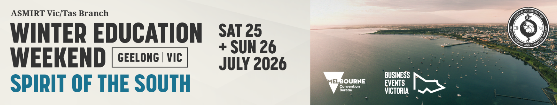

Abstract Submission Form
2026 Victorian Winter Education Weekend
ASMIRT Vic Branch committee welcomes all submissions for oral presentations for their 2026 Winter Education Weekend. Topics can include any research projects, interesting case studies or new practices/procedures. All submissions are to include a fully completed Abstract Submission Form.
- Oral presentations will run for duration of 11 minutes with 3 minutes question time. Time limits will be enforced so that the day runs to time.
- Please submit completed Abstract Submission Form, as a Word document, to the Winter Education Weekend Committee at James.rohan@gh.org.au
- Receipt of your submission will be acknowledged by email.
- Abstract submission closes: Friday 15 May 2026
Presenter name:
Email:
Mobile number:
Job Title:
Affiliation:
Co-author/s and their affiliations:
Modality: | □ Nuclear Medicine | □ Medical Imaging
Modality: | □ Radiation Therapy | □ Sonography
Modality: | □ Other: ______________________
University details: | University: ________________________________
University details: | Year level at 24 July 2026: ____________
Abstract type: | □ Scientific | □ Non-scientific (incl. case studies)
Abstract title:
Word limit: 25
Abstract body:
Word limit: 250
(not including references)

Scientific abstract structure:
Objectives, Methods, Results, Conclusion (and References if applicable)

Non-scientific abstract structure:
Headings not required
Biography:
Word limit: 100
As this will be used to introduce you (if successful) please write in the third person eg Mary is…

