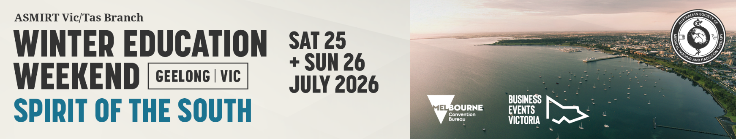

Case Race Submission Form
- Victorian Winter Education Weekend
ASMIRT Vic Branch Committee welcomes all submissions for the Case Race. Keep your eyes out for any interesting cases and join the Winter Weekend Case Race.
The Case Race will feature a series of short case study presentations delivered one after another, showcasing a variety of interesting and educational cases.
Share a short presentation, 4 minutes duration (4 - 6 slides) with 1 minute Q&A, featuring an interesting case history or a set of interesting images that would be of interest across all modalities.
- Case Race presentations will run for 4 minutes, followed by 1 minute of question time. Time limits will be strictly enforced to ensure the program runs to schedule.
- Please submit completed Race Case Submission Form, as a Word document, to the Winter Education Weekend Committee at James.rohan@gh.org.au
- Receipt of your submission will be acknowledged by email.
- Case Race submission closes: Tuesday 30 June 2026
Presenter name:
Email:
Mobile number:
Job Title:
Affiliation:
Modality: | □ Nuclear Medicine | □ Medical Imaging
Modality: | □ Radiation Therapy | □ Sonography
Modality: | □ Other: ______________________
University details: | University: ________________________________
University details: | Year level at 24 July 2026: ____________
Case Race title:
Word limit: 25
Case Race description:
Word limit: 250

Biography:
Word limit: 100
As this will be used to introduce you (if successful) please write in the third person eg Mary is…

