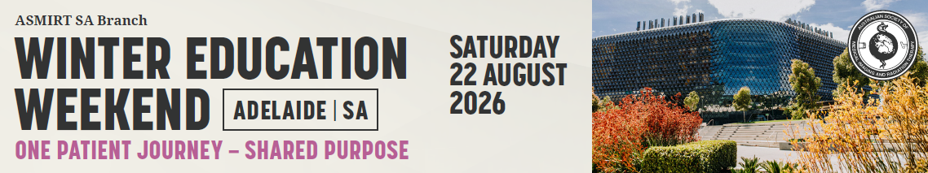

Abstract Submission Form
2026 SA Branch Winter Education Weekend
The ASMIRT SA Branch committee welcome all submissions for oral presentations for their 2026 SA Branch Winter Education Weekend. Topics can include any research projects or interesting case studies that you have prepared as an assignment or personal interest.
We are seeking presentations that align with One Patient Journey – Shared Purpose but are not limited to:
- Collaboration and patient care
- How Diagnostic and RT can approach same disease/condition
- What are the challenges and successes from these areas?
- What are the shared purposes of creating positive patient experiences to support vulnerable/anxious patients with human centred care in high tech professions?
All submissions are to include a fully completed Abstract Submission Form.
- Oral presentations will run for duration of 12 minutes with 3 minutes question time. Time limits will be enforced so that the day runs to time.
- Please submit completed Abstract Submission Form to the ASMIRT SA Branch at santbr@asmirtcommittees.org
- Receipt of your submission will be acknowledged by email.
- Abstract submission closes: Tuesday 30 June 2026
Presenter name:
Email:
Mobile number:
Affiliation:
Co-author/s and their affiliations:
Modality: | □ Nuclear Medicine | □ Medical Imaging
Modality: | □ Radiation Therapy | □ Sonography
Modality: | □ Other: ______________________
University details: | University: ________________________________
University details: | Year level at 21 August 2021: ____________
Abstract type: | □ Scientific | □ Non-scientific (incl. case studies)
Abstract title:
Word limit: 25
Abstract body:
Word limit: 250
(not including references)

Scientific abstract structure:
Objectives, Methods, Results, Conclusion (and References if applicable)

Non-scientific abstract structure:
Headings not required
Biography:
Word limit: 100
As this will be used to introduce you (if successful) please write in the third person e.g. Mary is…

