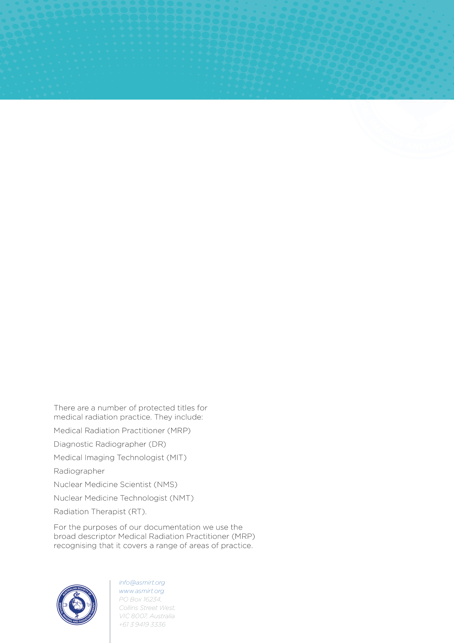
VARIAN AWARD NOMINATION FORM

Instructions for preparing nomination.
The nomination form must be filled in electronically. Any queries regarding the nomination should be directed to the ASMIRT Radiation Therapy Reference Group via tanya.morgan@asmirt.org.
Email the completed nomination form (single PDF document) to scholarships@asmirt.org with the subject line “Varian Award Nomination”.
Closing date for nominations is 30 October

Section 1: Award Criteria
The prestigious Varian Award recognises exceptional contributions to the field of Radiation Therapy.
The award honours an outstanding Radiation Therapist who has made a significant contribution to the advancement, promotion and development of the profession.
The award criteria align with the aims and values of ASMIRT and recognise excellence across the following areas:
- Strength and Excellence in Radiation Therapy
Demonstrates outstanding initiative and consistently performs their duties to a high standard. Identifies opportunities for improvement and develops or implements solutions that enhance the efficiency, quality or delivery of practice.
- Promotion and Advancement of Radiation Therapy
Actively contributes to the promotion and advancement of the profession through their work and broader professional activities. Fosters positive relationships and interactions with patients, students, universities, other health professionals, professional organisations and regulatory bodies.
- Commitment to Professional Development
Demonstrates a strong commitment to their own continuing professional development and actively supports, encourages and facilitates the professional development of others.
- Teamwork and Leadership
Demonstrates positive, respectful and effective behaviours as a team member and/or leader. Supports colleagues, contributes constructively to the team and communicates and follows up with others in a timely and appropriate manner.
- High Standards of Professional Practice and Proficiency
Demonstrates reliability, integrity and respect in all aspects of professional practice. Provides a high-quality, compassionate and professional service to patients and colleagues, while maintaining confidentiality and privacy. Communicates respectfully, listens to the needs of others and demonstrates a commitment to patient-centred care.

Section 2: Nomination Details
I wish to nominate:
Name
Position Title
Place of Work
E-mail
Has the nominee been a member of ASMIRT for five (5) years or more?
☐ Yes
☐ No
☐ Unsure

Section 3: Nominator Details
Name
Position Title
Place of Work
E-mail
Relationship to the Nominee

Section 4: Nomination Criteria
Please provide comments outlining the reasons for your nomination under each criterion. Your responses should refer to the award criteria outlined above and, where possible, include specific examples or situations that demonstrate how the nominee has met or exceeded each criterion.

- Strength and Excellence in Radiation Therapy
______________________________________________________________________

- Promotion and Advancement of Radiation Therapy
______________________________________________________________________

- Commitment to Professional Development
______________________________________________________________________

- Teamwork and Leadership
______________________________________________________________________

- High Standards of Professional Practice and Proficiency
______________________________________________________________________

Section 5: Resume
Please provide a current resume for the nominee.

