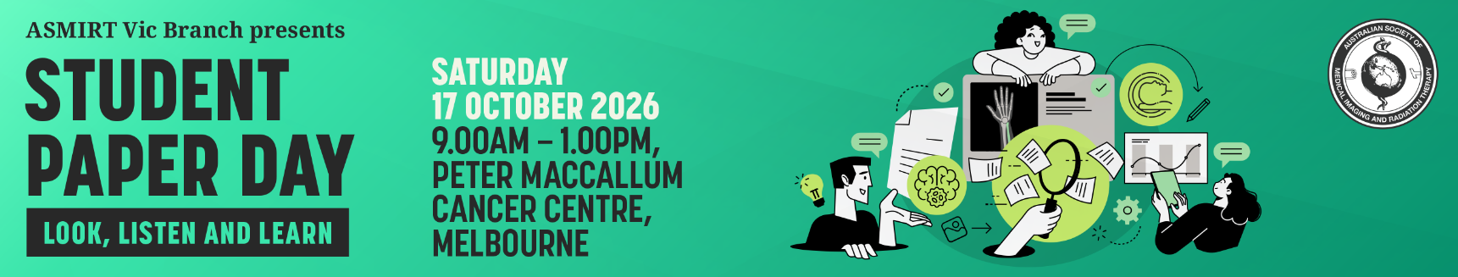

Abstract Submission Form
The ASMIRT Vic Branch committee welcomes all submissions for oral presentations for the annual student paper day. Awards will be given for the best two/three oral presentations. Award includes 12-month membership to the ASMIRT and registration to the next ASMIRT annual conference. The successful student members will represent Victoria in the ASMIRT 2027 Student Conference held in Melbourne from 14 – 17 April 2027 and compete for the National Student Prize. All talks must be presented live and in front of an audience. Online and pre-recorded presentations are not permitted.
All submissions are to include a fully completed Abstract Submission Form.
- Oral presentations will run for duration of 11 minutes with 3 minutes question time. Time limits will be enforced so that the day runs to time.
- Please submit completed Abstract Submission Form to the ASMIRT Vic Branch at steve.lacey@asmirt.org
- Receipt of your submission will be acknowledged by email. You will be notified of acceptance by Monday 28 September 2026.
- Abstract submission closes: Sunday 20 September 2026
Presenter name:
Email:
Mobile number:
Affiliation:
Co-author/s and their affiliations:

Modality: | □ Nuclear Medicine | □ Medical Imaging
Modality: | □ Radiation Therapy | □ Sonography
Modality: | □ Other: ______________________
University details: | University: ________________________________
University details: | Year level at 17 October 2026: ____________
Abstract type: | □ Scientific | □ Non-scientific (incl. case studies)
Abstract title:
Word limit: 15
Abstract body:
Word limit: 250
(not including references)

Scientific abstract structure:
Objectives, Methods, Results, Conclusion (and References if applicable)

Non-scientific abstract structure:
Headings not required
References:
References should be included if they support the abstract and must be directly cited in the abstract using the Vancouver referencing style as used by JMRS.
Biography:
Word limit: 100
As this will be used to introduce you (if successful) please write in the third person
e.g. Mary is…

